Bahrain PDPL Compliance for Log360
Strengthen data protection and meet Bahrain PDPL compliance with Log360.
Region: Bahrain | Type: Data Privacy | Category: Compliance | Pricing: Free

Overview
The Bahrain PDPL compliance extension in Log360 helps organizations meet the Bahrain Personal Data Protection Law (Law No. 30 of 2018), Bahrain's national data protection law requiring written consent for personal data processing and granting data subjects rights of access, rectification, and erasure by providing centralized log management, real-time threat detection, and data access monitoring. The platform supports Bahrain PDPL requirements for personal data access control, data security and breach detection, privilege management, file integrity monitoring, network security, audit logging, and database protection.
For Personal Data Access Control, Log360 monitors user authentication events, failed access attempts, Active Directory logons, remote desktop sessions, and user access patterns to track who accesses personal data systems. To address Data Security and Breach Detection, the platform detects threats through real-time correlation of antivirus alerts, FireEye and Trend Micro threat events, Unix threats, and network attack reports for breach identification. The extension also supports User Account and Privilege Management by providing capabilities that tracks user account changes, group membership modifications, SUDO command usage, and privilege assignments across Active Directory, Windows, and Unix platforms to enforce data access controls.

Key Features
- Data File Integrity and Modification Tracking: Log360 monitors file changes, permission modifications, failed access attempts, removable disk usage, and registry changes to detect data integrity violations.
- Network Security and Cross-Border Transfer Controls: Log360 captures network device events, firewall policy changes, attack reports, and perimeter activity to control and evidence cross-border data transfer compliance.
- Audit Logging and Accountability Records: Log360 centralizes Windows events, process tracking, policy change records, and GPO audit trails to create a comprehensive compliance evidence repository.
- Database Personal Data Protection: Log360 monitors database logon events, DDL and DML operations, permission denied reports, and Oracle and MSSQL audit trails to protect stored personal data from unauthorized processing.
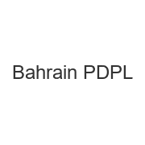

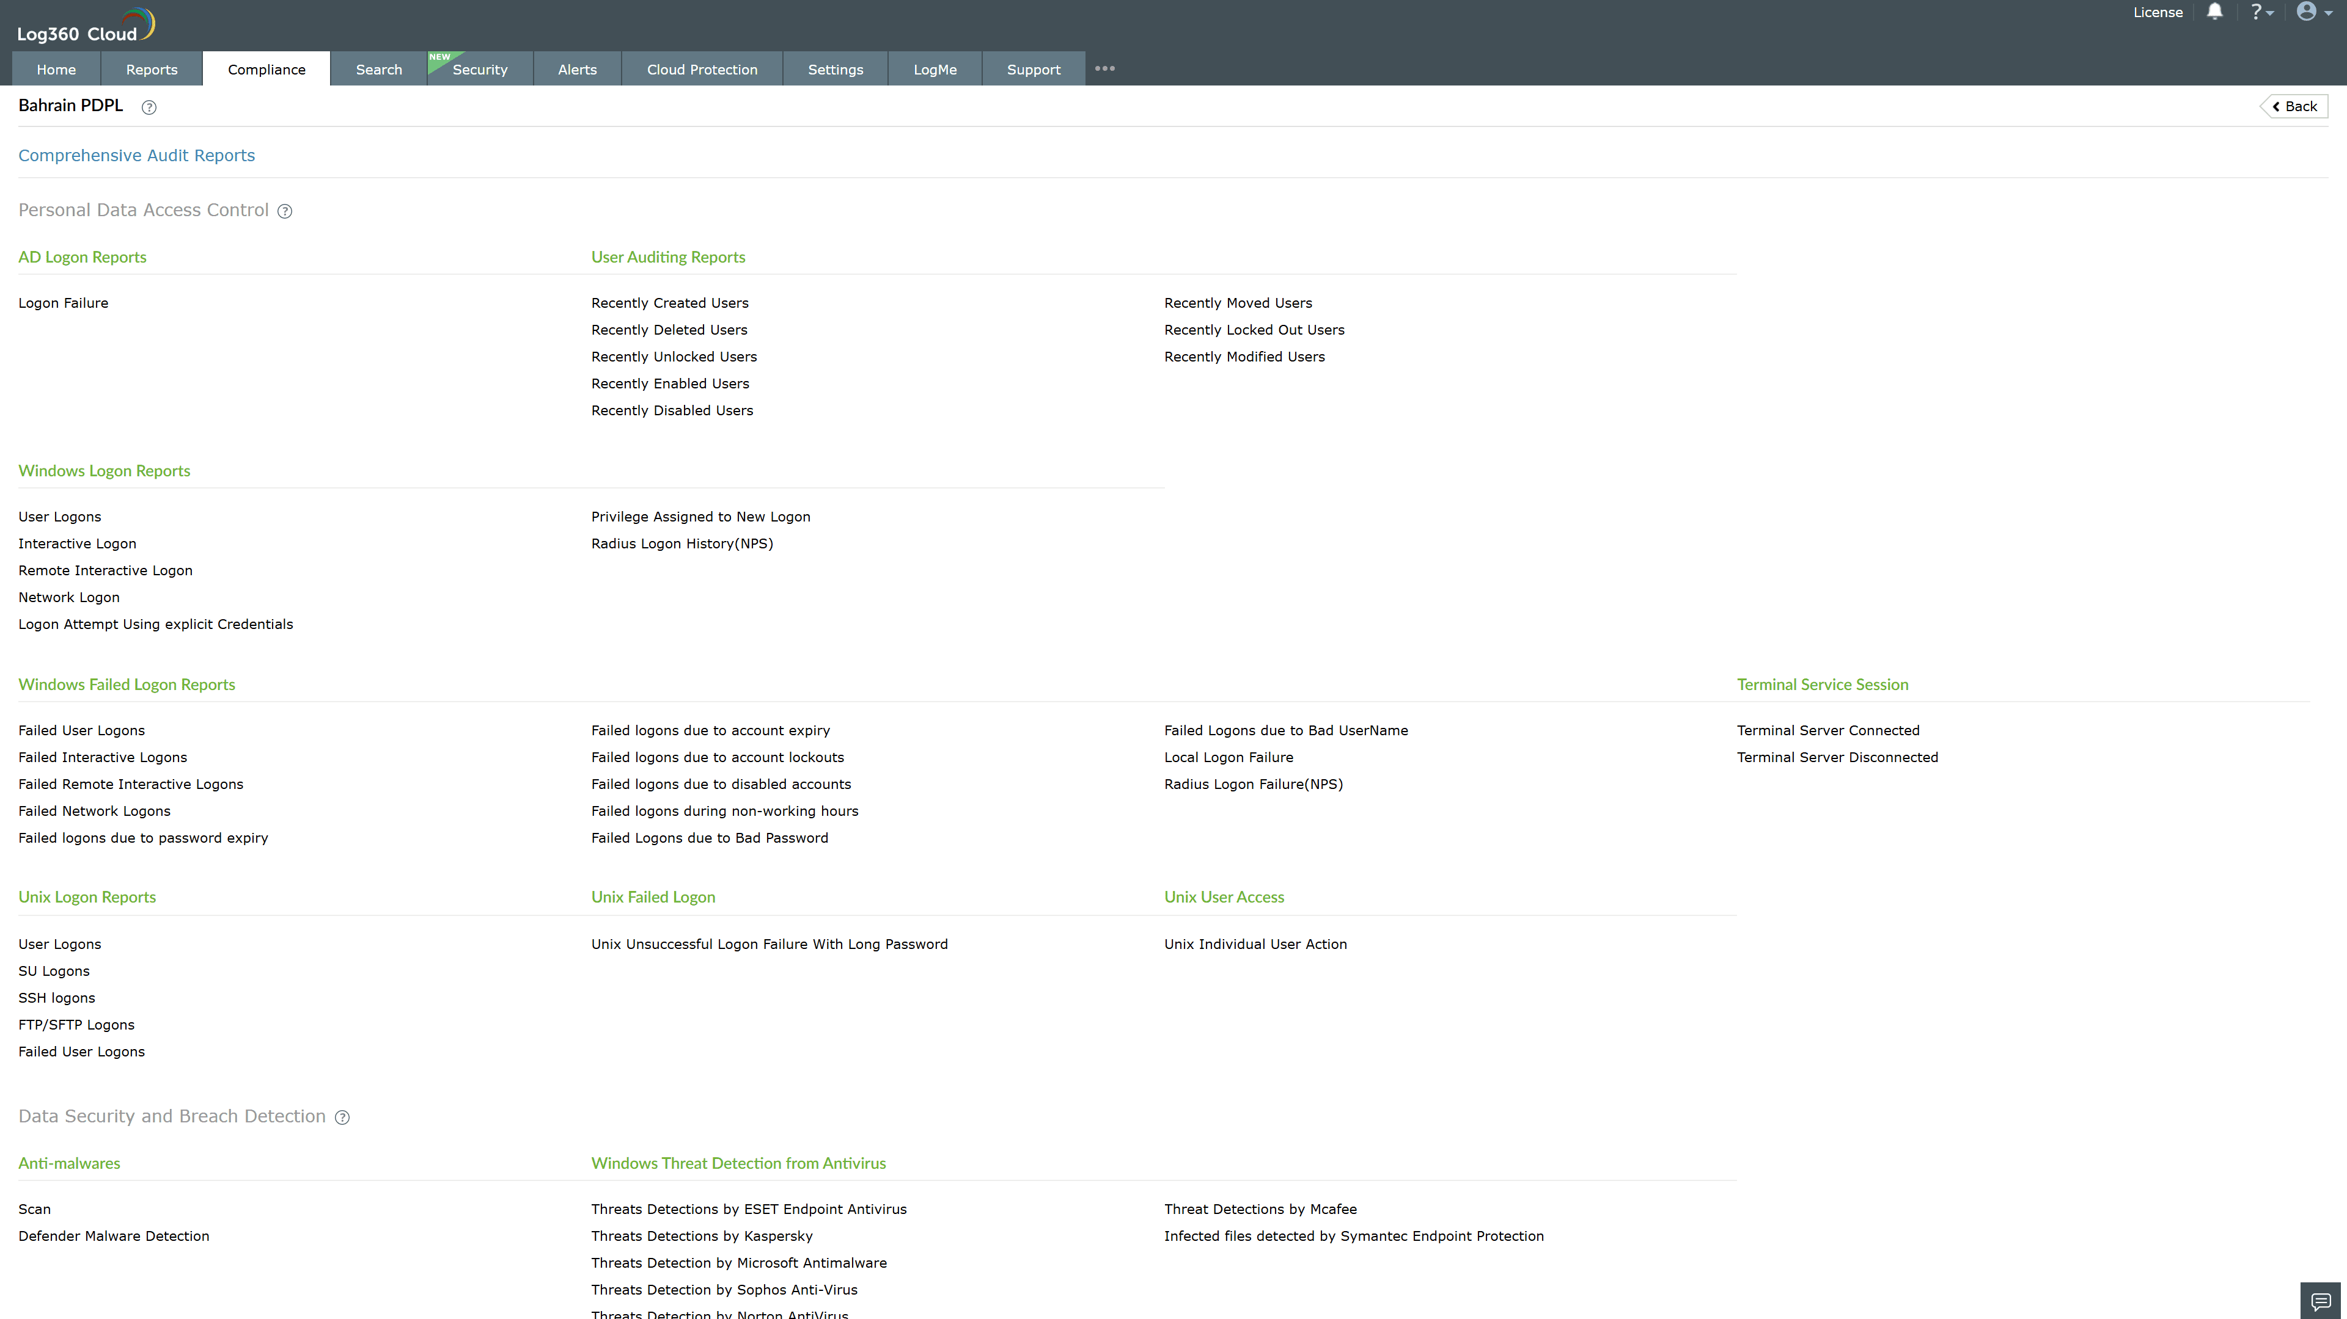
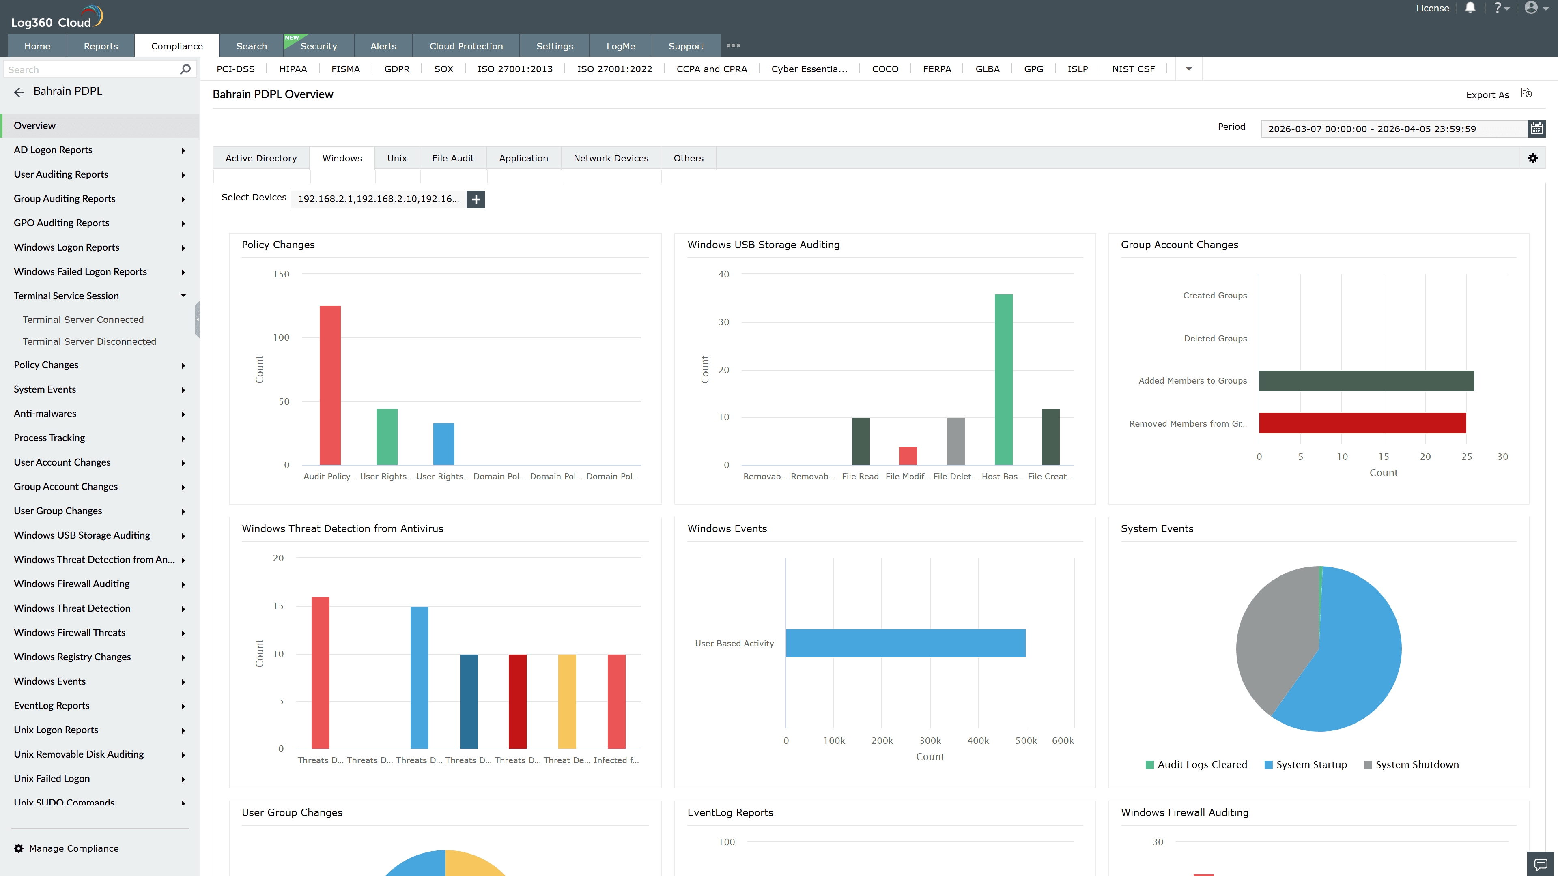
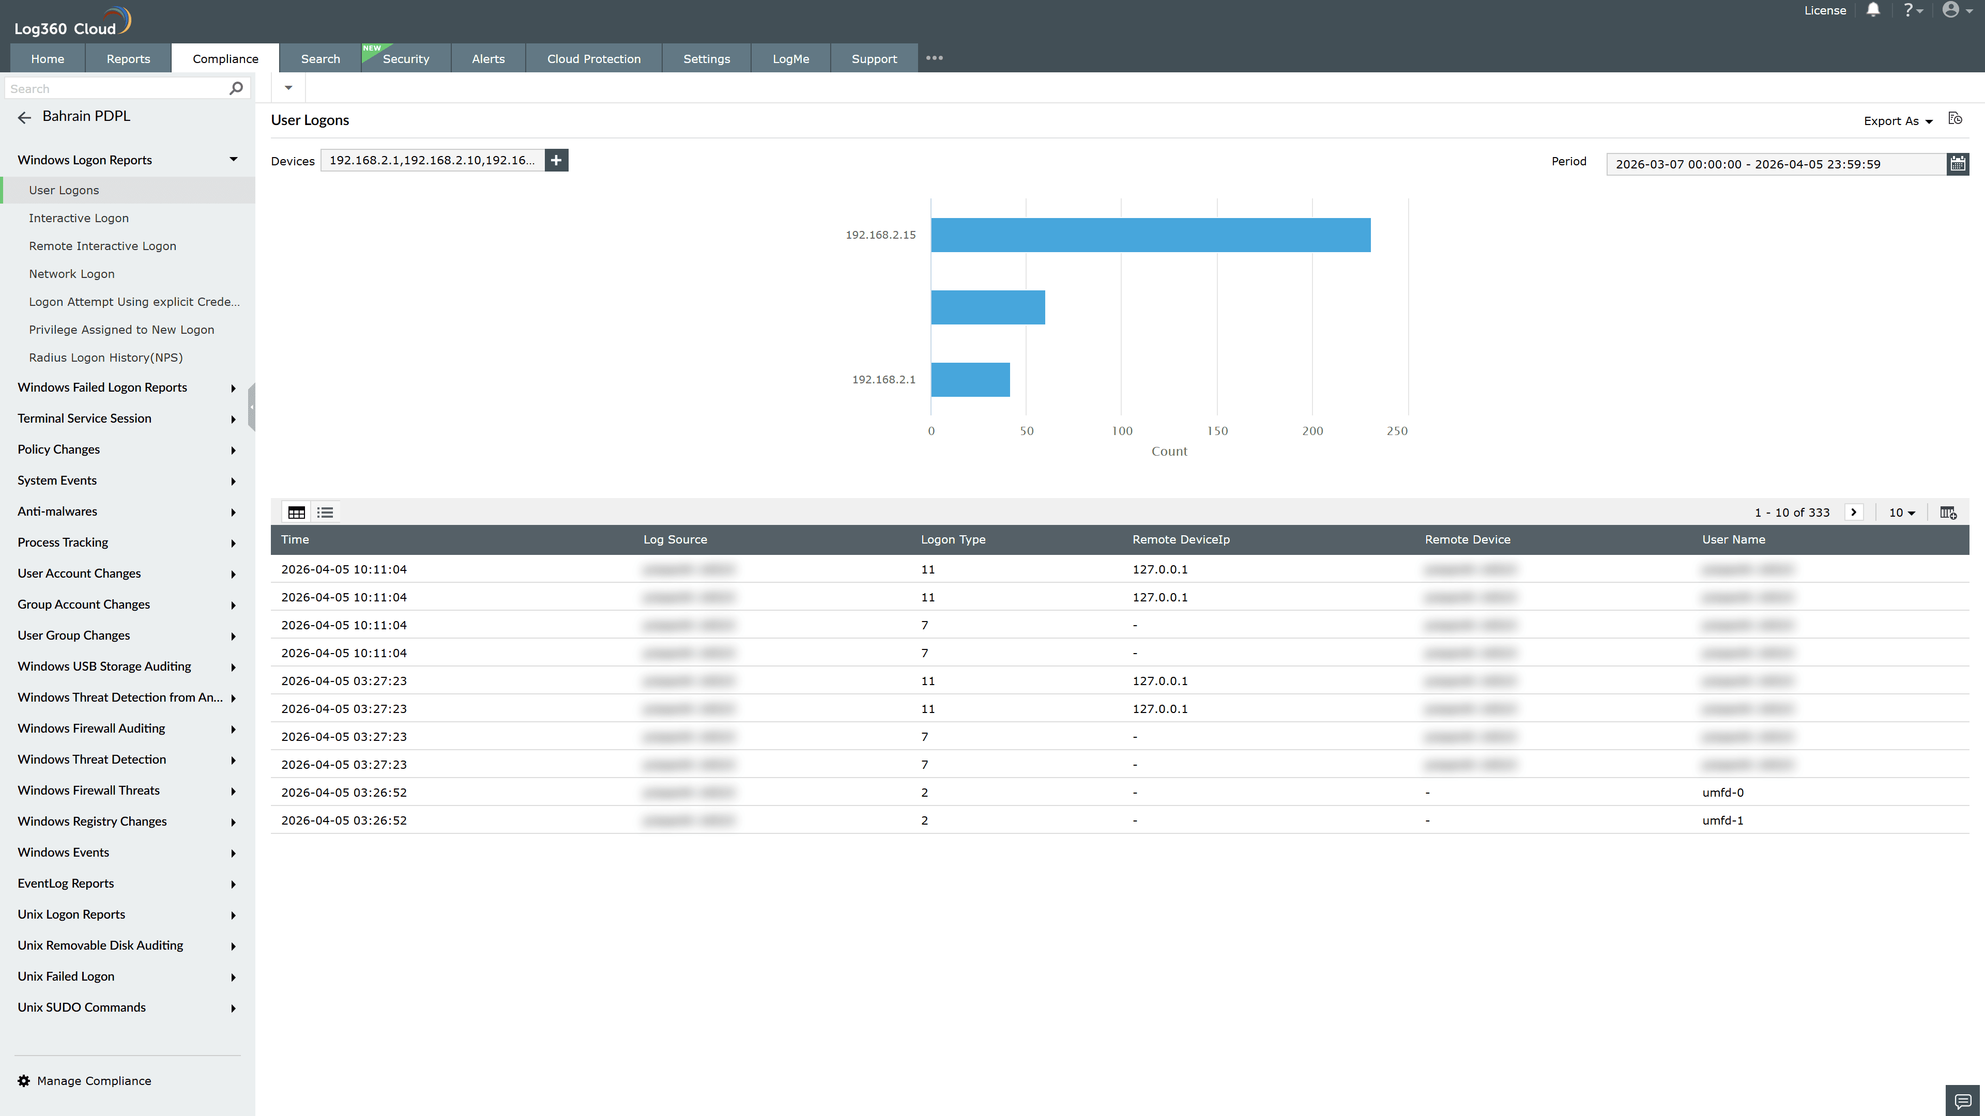
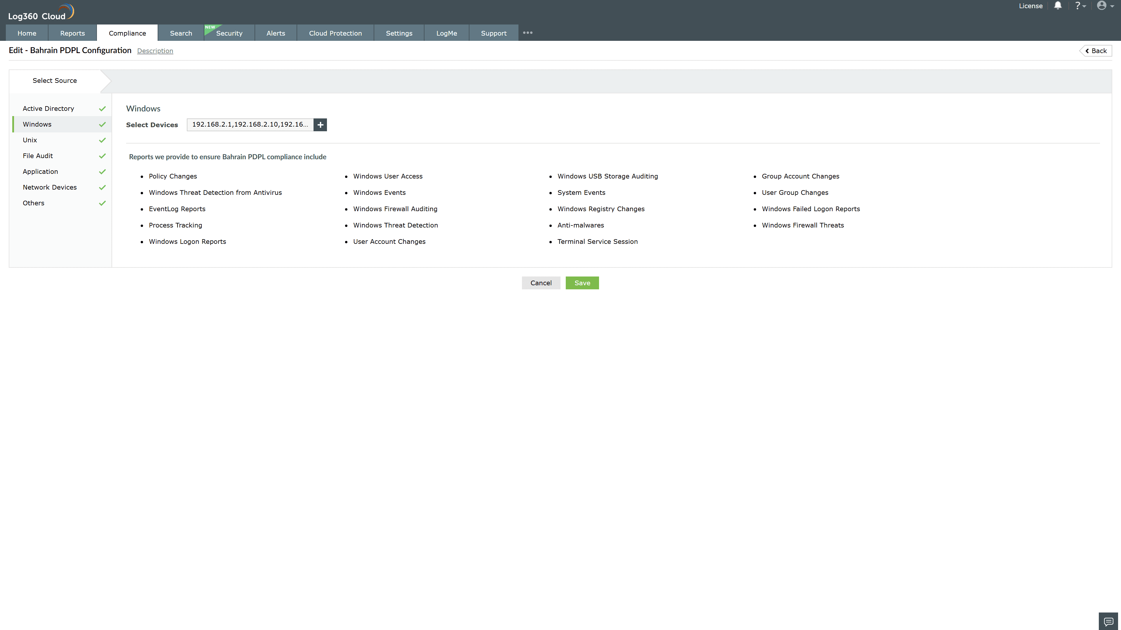
Valid Submission : Yes
Supported Editions : Free, Basic, Standard, Professional, MSSP
Help Document : https://www.manageengine.com/log-management/help/integrations/compliance-extensions.html
Help Video : Not provided
Tags : Log360, Compliance, Privacy monitoring, Data privacy, Regulatory compliance
Supported DCs : US, IN, JP, CA, AU, UK and EU
Privacy Policy:
Terms of Service:
Release Notes:
Predefined reports for the Bahrain PDPL.

